**Perception on the Effect of Exercise on Psychological Wellbeing of Undergraduate Students in the University of Ilorin Analysis**

EXECUTIVE SUMMARY

The culminating project of a recent University of Ilorin graduate comprises a survey involving 300 students aged 16 and above. The objective is to explore perceptions regarding the impact of exercise on the psychological wellbeing of undergraduate students. Participant perspectives delve into factors such as exercise intensity, duration, frequency, mood, stress, and knowledge/awareness of the psychological benefits of exercise.

These findings collectively illuminate a holistic appreciation for the psychological benefits of exercise among the surveyed graduates. The reasons provided offer valuable insights into the nuanced ways in which physical activity positively impacts various facets of mental and emotional wellbeing for instance 83% believe in the cognitive benefits of regular exercise, indicating a recognition of its positive impact on concentration and focus, 74% acknowledge exercise's effectiveness in reducing tension, reinforcing the widely recognized stress-relieving properties of physical activity, 77% find exercise to be an effective means of relaxation, underscoring its role in providing a reprieve from daily stressors, An overwhelming 94% personally believe in the transformative power of exercise, emphasizing the individual conviction in its positive effects and A resounding total of 97% agree that regular exercise is an effective tool for managing and reducing stress levels,74% report feeling more relaxed after engaging in high-intensity exercise, reinforcing the notion that exercise serves as a potent stress-reliever, 76% attribute an enhanced overall sense of well-being to vigorous exercise, underlining the multifaceted positive effects of intense physical activity, 80% report a boost in energy and motivation through regular exercise, highlighting the role of physical activity in sustaining vitality, indicating a collective understanding of its stress-alleviating properties, 80% report a boost in energy and motivation through regular exercise, highlighting the role of physical activity in sustaining vitality. These insights are instrumental in shaping targeted interventions and programs aimed at promoting mental health through exercise.

INTRODUCTION

In an era where the intersection of physical activity and mental health is gaining paramount importance, this study emerges as a beacon of insight. Undertaken as the final project by a recent graduate from the University of Ilorin, this research delves into the profound realm of perceptions surrounding the effects of exercise on the psychological wellbeing of undergraduate students.

Conducted through a meticulous survey involving 300 students aged 16 and above, this study navigates the nuanced landscape of participant perceptions. The focal points of exploration encompass exercise intensity, duration, frequency, alongside considerations of mood, stress, and the depth of knowledge and awareness regarding the psychological benefits of exercise.

SURVEY KEY FINDINGS

Within the cohort of 300 survey participants, the demographic breakdown revealed 58% as male and 42% as female, with an average age of 23.72 and the youngest participant being 16 years old. The participants represented three faculties—Education, Engineering, and Management Science. Notably, Education emerged as the predominant faculty with 50% of the participants, and among the academic levels, 300-level students exhibited the highest engagement, constituting 15% of the total participants.

In terms of exercise habits, 41% (123 students) reported engaging in physical activity once or twice a month. Within this group, 27% exercised several times a week, with 18% being male and 9% female indicating some gender-based disparities in exercise frequency. The age range of 21-25 was prominently represented in the survey, showcasing a concentrated participation in this demographic slice.

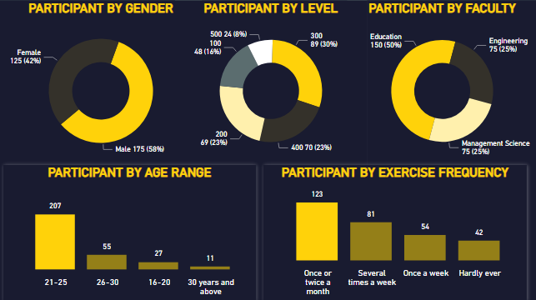

PROBLEM RESOLUTION

Though with the little participation the survey still illuminated positive perceptions and practices related to exercise and psychological wellbeing among the surveyed graduates, certain areas could benefit from targeted interventions. Here are actionable strategies to address identified aspects and enhance overall holistic wellbeing.

1. Implementing outreach and tailored programs to engage older participants, emphasizing the relevance and benefits of exercise across all age brackets will engage more older demographics.
2. Launch awareness campaigns highlighting the benefits of frequent exercise and provide incentives for consistent engagement, fostering a culture of regular physical activity.
3. Organizing stress management workshops, providing students with practical tools and strategies to integrate exercise seamlessly into their stress relief routines will reduce student stress level and increase wellbeing chances.
4. Introduce a variety of exercise programs to cater to diverse preferences, including high-intensity options, mindfulness exercises, and group fitness activities. This ensures inclusivity and meets the varied needs of the student body.
5. Implement periodic assessments and surveys to gauge the effectiveness of wellness initiatives. Solicit feedback from participants to understand their experiences and preferences, enabling continuous improvement and adaptation.

CONCLUSION

From the survey, we've learned how exercise boosts confidence and wellbeing and also a cornerstone for mental and emotional wellbeing among undergraduates. Recognizing the positive impact of exercise on mental health and stress relief, the results suggest the importance of prioritizing overall wellbeing in our environment.